In simple words, differentiation or differentiated instruction is a method in which lesson planning and instructions are offered to students with a vast range of techniques to increase their study skills. Hence, differentiated instruction strategies are necessary for the students to be able to learn.
- Taken from teach-nology.com

Steps to Differentiation

This is to be used as a quick and dirty guide to differentiating different lessons in the classroom. The following has been taken from teach-nology.com

Step 1- Know Your Students

Determine the ability level of your students.

This can be done by surveying past records of student performance to determine capabilities, prior learning, past experiences with learning, etc.

Survey student interests.

It is also important to get to know your students informally. This can be done by an interest inventory, an interview/conference, or asking students to respond to an open-ended questionnaire with key questions about their learning preferences (depending on the age group).

Is behavior management a problem?

This is key when planning for activities that require less structure. However, it is still important to determine learning styles and preferences for students who may have a hard time controlling their behaviors. Sometimes knowing preferences can help to motivate students to attend to any tasks that are presented.

Step 2- Have a Repertoire of Teaching Strategies

Because "one size does not fit all," it is imperative that a variety of teaching strategies be used in a differentiated classroom. Among many teaching strategies that can be considered, there are four worth mentioning: direct instruction, inquiry-based learning, cooperative learning, and information processing models.

Direct Instruction

This is the most widely used and most traditional teaching strategy. It is teacher centered and can be used to cover a great amount of material in the amount of time teachers have to cover what students need to learn. It is structured and is based on mastery learning. More information can be found on:

http://www.teach-nology.com/teachers/methods/models/

Inquiry-based Learning

Inquiry-based learning has become very popular in teaching today. It is based on the scientific method and works very well in developing critical thinking and problem solving skills. It is student centered and requires students to conduct investigations independent of the teacher, unless otherwise directed or guided through the process of discovery. For more information, go to:

http://www.teach-nology.com/currenttrends/inquiry/

Cooperative Learning

Probably one of the most misunderstood strategies for teaching is "cooperative learning." Yet, if employed properly, cooperative learning can produce extraordinary results in learning outcomes. It is based on grouping small teams of students heterogeneously according to ability, interest, background, etc. However, one of the most important features of cooperative learning is to pick the best strategy that will be used to assign the task for students to accomplish. The more popular strategies include JigsawII, STAD-Student Teams, or Group Investigation. For more information, go to:

http://www.teach-nology.com/currenttrends/cooperative_learning/

Information Processing Strategies

Teaching students "how to" process information is a key factor in teaching students how to strategically organize, store, retrieve, and apply information presented. Such strategies include, but are not limited to, memorization, KWL, reciprocal teaching, graphic organizing, scaffolding, or webbing. More information on this topic can be found at:

http://www.teach-nology.com/teachers/methods/info_processing/

Step 3- Identify a Variety of Instructional Activities

Engaging students in the learning process using activities that motivate and challenge students to remain on task is probably one of the most frustrating events in the teaching learning process. But if you know your students' profiles, you have a better chance at keeping them on task to completion of any given assignment or activity. In a differentiated classroom, activities are suited to the needs of students according to the mixed ability levels, interests, backgrounds, etc. For example, if you have English language learners in your class, you need to provide activities that are bilingual in nature or that provide the necessary resources for students to complete the activity with success. Good activities require students to develop and apply knowledge in ways that make sense to them and that they find meaningful and relevant. Ideas for activities can be found at:

http://www.teach-nology.com/teachers/lesson_plans/

Step 4- Identify Ways to Assess or Evaluate Student Progress

Once again, we cannot assume that "one size fits all." As a result, varying means of student assessment is necessary if students are to be given every opportunity to demonstrate authentic learning. Authentic assessment has been around for a long time and is now taking the limelight as we attempt to measure students' progress in a fair and equitable way. A variety of assessment techniques can include portfolios, rubrics, performance-based assessment, and knowledge mapping. For more information on this topic go to:

http://www.teach-nology.com/currenttrends/alternative_assessment/

Differentiation Strategies

- KNOW YOUR LEARNER
  - All students are different, there is no strategy that will work for all students.
  - Keep in mind your students’ interests, preferences, readiness, and needs
- Create high challenging, low threatening environments
  - Expectations for all students must be consistently high
  - “Shoot for the for the moon, because even if you miss you will be amongst the stars”
- Adjust the teacher's activities according to the student's needs, preferences, past experiences, skills, and knowledge
  - By paying attention to the students, teachers are able to adapt instruction, and activity to meet the needs of all learners
- Understand the MUST KNOWS, SHOULD KNOWS, and NICE TO KNOWS of any given lesson or curriculum
  - By knowing what all learners must know, what learners should know, and what would be nice to know teachers are able to discern what information needs to be passed on, to what student.
- Flexible groupings
  - Allows students to work in groups that are dissimilar to themselves. Encourages Peer Tutoring, and can be a less threatening way for students to understand troubling concepts.
  - Teachers must ensure however that the groupings are not static.
- Learning Centers
  - Allow teachers to present information in a variety of ways, that engage different learning styles.
- Independent Study
  - Allows students who have demonstrated mastery of given concepts to further increase their knowledge in given areas.
  - Teachers need to be completely certain that students have mastered the content however, for this strategy to work.
- Tiered Assignments
  - Tasks are similar, but range in complexity.
- Adjusting Questions
  - Teachers adjust the levels of questioning based on the individual child. If a student is able to handle more complex questions about a given content, then the teacher may ask high order questions from the Bloom’s Taxonomy. If a student is only able to handle lower level questions the teacher would adjust accordingly
- Choice Activities
  - Teachers can give students options on how they would like to demonstrate their understanding of a given concept. This can aid in increasing student motivation on different subject matter
Additional Resources on Differentiation

http://www.teach-nology.com/tutorials/teaching/differentiate/
This site provides teachers with a great resource for information on differentiation. The steps found on this site are used as a guide to help teachers.

http://caroltomlinson.com/Presentations/ASCD_LowPrep.pdf
This is a presentation that is done by Carol Tomlinson about utilizing differentiation with low preparation on the teacher’s part.

For additional resources and strategies please see attached documents.

Books on Differentiation

The Differentiated Classroom: Responding to the Needs of All Learners, 2nd Edition (2014)
Carol Ann Tomlinson
ISBN: 978-1-4166-1860-7

A Differentiated Approach to the Common Core: How do I help a broad range of learners succeed with challenging curriculum? (ASCD Arias) (2014)
Carol Ann Tomlinson & Marcia B. Imbeau
ISBN: 978-1-4166-1979-6

Assessment and Student Success in a Differentiated Classroom (2013)
Carol Ann Tomlinson & Tonya R. Moon
ISBN: 978-1-4166-1617-7

Task Rotation: Strategies for Differentiating Activities and Assessments by Learning Style: A Strategic Teacher PLC Guide (2011)
Harvey F. Silver, Joyce W. Jackson and Daniel R. Moirao
ISBN: 978-1-4166-1188-2

Leading and Managing a Differentiated Classroom (2010)
Carol Ann Tomlinson, Marcia B. Imbeau
ISBN: 978-1-4166-1074-8

Exploring Differentiated Instruction (The Professional Learning Community Series) (2009)
Cindy A. Strickland
ISBN: 978-1-4166-0834-9

Professional Development for Differentiating Instruction: An ASCD Action Tool (2009)
Cindy A. Strickland
ISBN: 978-1-4166-0811-0

Reference List

http://www.teach-nology.com/tutorials/teaching/differentiate/

http://www.teachhub.com/top-ways-implement-differentiated-instruction-strategies

http://www.ascd.org/ASCD/pdf/books/tomlinson2001_chapter6_errata.pdf

http://www.ascd.org/ASCD/pdf/siteASCD/publications/Differentiation_Is-IsNot_infographic.pdf

http://caroltomlinson.com/Presentations/ASCD_LowPrep.pdf

http://teachingasleadership.org/sites/default/files/Common-Pitfalls/P4_Low_and_High_Prep_Differentiation_Strategies.doc

http://www4.esc13.net/uploads/math/docs/podcast%20transcripts/LowPrep_DI_Strategies.pdf

http://cnweb.cn.edu/tedu/New%20Website%20Docs/Differentiatedinstructionstrategieskit.pdf

http://education.ky.gov/educational/diff/documents/strategiesthatdifferentiateinstruction4.12.pdf

https://www.aislusaka.org/uploaded/Differentiating_Strategies.pdf

Additional Figures

What differentiation is, and is not
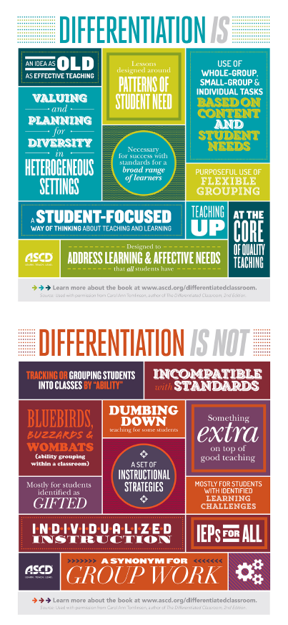

(Taken from ASCD.org)

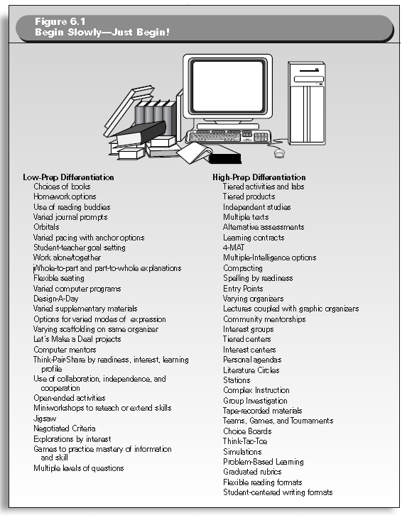
(Taken from How to Differentiate Instruction of Mixed Ability Classrooms)

